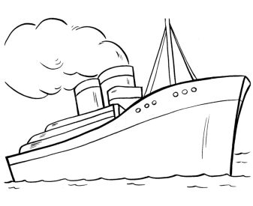
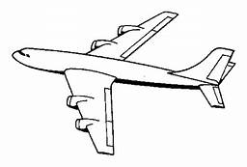
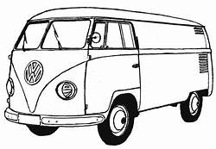
Bushy Run District Day Camp
“Land, Sea, and Air”
June 7,8,9, 2019
Norwin Elks
$45.00 per Cub Scout - $5.00 per Bushytail

ALL HEALTH FORMS MUST BE TURNED IN AT THE SAME TIME AS YOUR REGISTRATION!

ALL WALKERS CLEARANCES MUST BE TURNED IN AT SAME TIME AS YOUR REGISTRATION!
A Bushytail is a child of a staff member or walker.
To be a bushytail, Parent must be on staff or be a walker the day the bushytail is there.
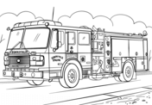
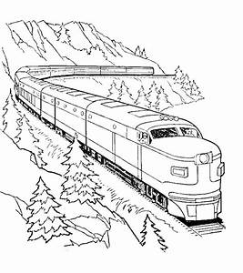

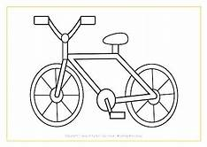
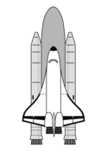
Bushy Run Day Camp
Land, Sea, Air
When: June 7, 8 and 9, 2019
Hours: Friday June 7, Saturday, June 8
From 9:00a.m - 3:00p.m.
Sunday 12:00pm to 4:00pm
Registration will begin promptly at 8:30a.m.
Friday & Saturday, June 7 – June 8
Registration will begin promptly at 11:45a.m.on Sunday

Where: Norwin Elks, Sandy Hill Rd, Manor, Pa.
Directions: The Norwin Elks is located on Sandy Hill Road which runs next to the turnpike in Manor. Parking at the Elks is limited to staff and walkers. It is best to car pool due to the limited number of parking spaces. We do not provide transportation to or from camp. Upon arrival at camp, parents should remain in their vehicles and drop off their scouts at the main circle to keep traffic flowing. Once at camp, they will be cared for by an exceptional Day Camp staff. Parking on Sunday will be announced on Saturday.

Who May Attend: All registered Lions, Tiger Cubs w/adult partner
. Note: Only registered Lions w/adult partner, Tiger w/adult partner, Wolves, Bears Scouts Webelos and AOL Scouts, may participate at the activity stations.

What does it cost? For 3 full days of Day Camp---Friday, Saturday and Sunday -$45.00
The fee includes the Day Camp t-shirt, 2019 Collectors Bushy Run Day Camp Patch, craft supplies, and a trained and enthusiastic staff willing to insure your son’s enjoyment. Additional shirts may be ordered for parents, walkers & Bushy Tails at a cost of $8.00/adult- S,M,L,XL /$9.00 XXL, $10.00 XXXL/ Child -S,M,L $7.00

Cub Scout Day Camp Mission Statement
Cub Scout Day Camp strives to support the purposes of Cub Scouting by providing each boy the opportunity to experience new things in a safe, outdoor environment, nurturing a spirit of teamwork and belonging, helping Packs provide an exciting summer program and HAVING FUN!

Camp Organization: Most Day Camp dens will be a combination of two or more PACKS to reach approximately 15-20 Scouts in size, depending on camp registration. Each pack WILL supply enough adult Walkers for a 1 adult to 5 Scouts or part thereof ratio for their own Cubs, with a minimum of 2 Walkers to comply with BSA 2-deep leadership requirements. Walkers are part of the mandated pack leadership and are not considered camp staff members. Each pack is primarily responsible for its own Scouts, but when in the activity stations, please be ready to help each other out. You will need to work together for many of the den duties, such as the opening or closing, and leading songs. It would build spirit for the whole den to decide on a yell and cheer together. Take advantage of this opportunity to meet other Scouting families in your area and share fellowship and
ideas.

Typical Camp Day: Staff arrives early to set up. Walkers arrive at least 15 minutes early, check in, receive camp Den Folder and proceed to flag pole or designated assembly area. Parents and campers arrive drive around and drop off camper at camp entrance a staff member will be there to meet the campers. Walkers take attendance. Opening ceremony, daily announcements, proceed to 1st station. Complete morning stations, lunch and lunch activity. Continue with final stations. Closing at flagpole. Walkers turn in camp folder with bag. This is a general guideline. There may be some variation to this outline.

Activity Stations: Activities at each station will be chosen to enhance the theme, may offer opportunities for rank advancements, and to HAVE FUN! Shooting Sports: Day camp or other Council sponsored Cub activity such as a parent-son weekend or resident camping at a council site are the ONLY opportunities for Cubs to earn the BB’s or Archery Belt Loops or Pins. Alternate program activities will be provided for those opting out of these activities. These program areas stress safety and proper use of the equipment, including respect for nature. BSA policies prohibit the use of targets resembling any living thing.

Lunch Time: Lunch will occur for all Dens at the same time daily. We will not have access to refrigeration, so bring coolers to store lunches in. Lunch period will also include a Quiet time.

Advancement and Recognition: While the primary focus for Day Camp is the opportunity for FUN in the outdoors, centered on a theme, most of the program will provide some activities to give campers a head start on ranks and activities in their handbooks, without shorting the fun of the theme. An itemized list of possible requirements will be available. It is the walker’s responsibility to make sure what a Scout has done is accurately recorded. Some Scouts may be absent or unable to do a requirement. Each Cub Scout’s advancements should be reported to his parent and den leader for verification for Awards. Any Belt Loops or Pins or other awards completed are awarded through the boy’s pack.
Participation Beads are awarded to each Scout at each station daily. Beads are kept on the name totem made the first day. Lost beads are usually not replaced. Registered Day Campers also receive a special day camp patch at the close of camp, to recognize their participation.

What is a Bushy Tail ? A Bushy Tail is a brother and/or sister of a registered day camp scout and whose parent is a Walker or Staff the day they attend. All Bushy Tails must remain in the Bushy Tail area at all times including lunch. They are not permitted to attend the stations. Bushy Tails must be 3 years old (must be potty trained), not to exceed the age of 10. We are not equipped to handle any sick child. Cost for a Bushy Tail? The fee for a Bushy Tail will be $5.00.

Pack Responsibilities: Your Pack Day Camp Coordinator will be asked to collect the registrations for your Pack and mail them to the Council Service Center as one package. Each Pack must provide a Den Leader/Walker for every 1 to 5 boys registered from their Pack. Your Pack does not have to send the same adult each day but there has to be at least one full time walker each day. These adults will be under the guidance of staff.

Pack Registration Responsibilities: The reservation and health forms provided must be completed and submitted for each scout, Bushy Tail and adult attending and mailed or given to the Council Service Center as one package. Each Pack must provide a Den Leader/ Walker for every 1 to 5 scouts per scout rank.
Den Leaders/Walkers:
Arrive on time. At the close of each day a walker must remain until their last boy is picked up by a parent or a carpool.

One walker from each camp den checks in each day to pick up their Dens bag. Each camp den will have its own bag, even if combined with another Pack to form one den.

Take attendance daily on sheet in folder. Turn in bag at close of each day.

Get your whole den to the activity stations on time. Walk together as a den. Help the station staff in each area. Be proactive. Don’t wait to be asked to assist the Scouts. You are a working den leader, as well as a walker.

Scouts will earn participation beads at each station. Tell the program staff how many boys you have, and they will give the beads to you to give the boys for their bead thong. Program staff will not replace lost beads. At the end of the day, place totem in bags so they are not forgotten at home.

STAY WITH THE Scouts AT ALL TIMES. If you are the only leader with a small group of Cubs, and you need to excuse yourself, make sure a leader form another pack in the den you are assigned to will watch you’re Scouts while you are away.

Maintain BSA required 2-deep leadership at all times, and enforce use of the Buddy System by the boys.

KEEP Scouts HYDRATED!! Report any illness or injury to Camp Director ASAP! Escort them to the first aid station, or send for First Aid, if the individual should not be moved. Inform Camp Director of any serious injury.

Change stations when you hear the signal – One long blast on the air horn.

Set an example. Live Scouting’s values. Follow Camp rules. Be positive. Have FUN!!

SMILE, IT WILL MAKE US ALL FEEL BETTER!
MORE RESPONSIBILITIES FOR WALKERS
You will need lunch each day. You will also need a magic marker to label your group’s belongings. Bring a cooler to keep your den or patrol’s lunches for the day. Two training sessions will be offered at the Norwin Elks. Den Leaders/Walkers will take attendance on sheet provided. They will also be responsible for supervision of the Scouts, assist them at all activities, be responsible for promoting Leave No Trace, and be prepared to have fun in the sun.

What should I bring to Day Camp? Each Scouts and Bushy Tail should bring a labeled, non-perishable lunch, water bottle – water is available to refill water bottles. Please label everything and put in their personal backpack. Labels should include full name and Pack number.
A Trading Post will be available at scheduled times to purchase snacks and souvenirs.

What do I wear to Day Camp? Shorts, shirts, jeans, socks, sport shoes, sneakers, walking shoes, sunglasses and hats.-- No sandals or open shoes.-- Remember to pack rain gear ( poncho) in the backpack as the activities continue unless there is severe weather. Day Camp T shirt (provided) and any hat are the uniform for Cubs. Please label everything and put in their personal backpack. Labels should include full name and Pack number.

Medication/First Aid: Any medications for Cubs or Adults must be left with the first aid attendant along with instructions for administering them. All walkers should find out about such special needs in order to get Cubs to the first aider as necessary. Epi-pens and inhalers stay with each Scout.

If a Camper becomes ill while at camp, the First Aider and Camp Director will decide if and when he should go home or to a medical facility. The Camp Director will contact the parents/guardians. First Aiders will supervise the cleaning and bandaging of minor cuts and scrapes and will apply ice to stings, bumps and bruises. The First Aider may not administer any medication of any kind unless supplied by the parent/guardian, prescribed in the camper’s name, with written directions from a physician. Please do not ask for any other medications.

MISC. RULES AND REGULATIONS
Rocks and sticks are to remain on the ground. A stick or rock that is picked up is likely to cause danger to the holder or another person.

No running in camp, unless it is for an activity.

No Pets allowed in camp in compliance with health and safety requirements.

NO KNIVES OR FLAMMABLE ITEMS are to be used by Scouts, and should not be in camp except as needed by Leaders and/or Staff members for specific camp programs.

NO Aerosol Cans are allowed in camp, including insect sprays.

No Smoking is allowed in camp per policy. Camps are considered a part of the Westmoreland Fayette Council and the Boy Scouts of America, which has a no smoking policy.

No Alcoholic beverages or Illegal drugs are allowed at camp. NO EXCEPTIONS.

Lost and Found: The Camp will maintain a lost and found area; the area will be at the trading post. Items may also be brought to the flagpole at opening and closing.

Camp Safety: Camp Program staff will wear all the same Tee-shirt . Program Staff are parent volunteers, like you, Boy Scouts, and leaders from local packs that have volunteered to work a program area. If there is a problem in camp, inform a staff member. They will be able to help you or know how to get someone who can help. In addition, local fire and rescue personnel, police and healthcare officials have been informed that camp is in progress in case of an emergency. An onsite first aid station is staffed by a qualified first aider. Camp headquarters maintains copies of health and permission forms for each person in camp – Scouts, volunteers, staff and siblings.

Buddy System: Cubs will utilize the buddy system at all times. A Cub does not go anywhere alone. Leaders will practice BSA required 2 deep leadership. Two leaders must be present with a youth at any time. No adult will be alone with a camper, sibling, or Junior staff.

Visitors: All visitors to camp will be required to sign in and out at camp Headquarters, and approved by Camp director or program director. Random wandering about camp compromises camp safety, and will not be allowed.

Emergency Plan: The Camp Director and Program Director will determine final emergency procedures. They will determine whether or not emergency procedures will be implemented. Everyone in camp should understand the PLAN and be ready to respond. The following general instructions will be supplemented at camp. For any emergency, remain CALM, send for the Camp Director and follow the Camp Staff’s instructions.

ACCIDENT OR ILLNESS; Administer First Aid with the limits of your qualifications. Send for Health Director or Camp Director. All injuries, cuts, scrapes, etc. must be seen by first aid. Non-emergencies can come to the first aid station with a buddy or an adult leader or Junior staff.

FIRE IN CAMP; Once the alarm is sounded (3 blasts on an air horn) all activity stations will close. Walkers need to account for all of their Cub Scouts. Proceed by Dens to the Flagpole for further instructions. Remain Calm.

LOST BOY; Once the alarm is sounded (3blasts on an air horn) all activity stations will close. Walkers need to account for all of their Cub Scouts. Remain at the station. Write down the report and send it with 2 runners to the camp Headquarters. Follow Camp Staff’s directions.

INCLEMENT WEATHER; Camp will continue during light rain, so all boys and persons in camp should come prepared with rain gear. If weather conditions become threatening, the Camp Director will decide if stations will close. Once the alarm is sounded (3 blasts on air horn) all activity stations will close. Walkers need to account for all of their Cubs. When all Cubs are accounted for, proceed to the designated camp shelter.

ANIMALS AND OTHER HEALTH HAZARDS: There has been an increase in West Nile Virus during recent summers, and boys should be aware to never mess with dead birds or animals, but report them to an adult. Occasionally local pets or stray animals wonder into camp. Campers should leave the animals alone.

Bushy Run Day Camp Registration checklist
This is a checklist of what forms and money
MUST be turned in by May 1, 2019
PLEASE PLACE PACK NUMBER ON ALL FORMS.
Forms that must come with your registration:
Health form for: (please place Pack number on each health form)
Lion Cub
Lion Cub Adult Partner
Tiger Cub
Tiger Cub Adult Partner
Wolf, Bear, Webelos, AOL Scouts
All Adult Walkers
Bushytails
COPIES of PA clearances
Form titled: Pack Registration Package
This form is your total due form and a lot of important information
Registration forms for
- Lion Cub
- Tiger Cub
- Wolf, Bear, Webelos/AOL Scouts
- All Adult Walkers
- Bushytails
Moneys due at registration: Cub Registration @ $ 45.00 per boy
Bushytails Registration @ $5.00 per child
Pack Registration Package
Dear Day Camp Coordinator,
To help us organize the dens and patrols for Day Camp, please collect all the registrations and complete the following forms. When completed, turn the registrations and this form in to the Council Service Center. All registrations must be turned in by May 1, 2019. Please make extra copies of these sheets if needed.
Adults attending Day Camp on June 7, 8, 9, 2019

Scouts attending Day Camp @ $45.00 per boy $

Bushy Tails attending Day Camp @ $5.00 per tail $

________Adult Extra Tee-shirts @ 8.00, 9.00, 10.00 per size $_________

________Child Extra Tee-shirts @ 7.00 $__________

PACK NUMBER____________ Total due $

Pack Camp Coordinator Phone ( ) - .

E-mail Address

Deliver this completed form to:
Westmoreland Fayette Council
2 Garden Center Drive
Greensburg, PA 15601-1393
(724) 837-1630

If you have any questions, please call:
Day Camp Director – Arlene Snyder - (724) 863-3213
Marilyn Martinelli - (412-310-8497)
Program Director – Karen Shupe - (412) 297-3719
District Executive – Paul Rock - (724) 837-1630
Steps that need to be done for early dismissal of a Scout from Day Camp:

If you have an early dismissal of a Scout from camp there are a few things that must be done before camp and before dismissal can happen.

- Do not leave your group
- Parents picking up early must report to the office to pick up their Scout.
- They must have 2 forms that are included in registration packet filled out and given to day camp walker of your boys den.
- The walker should drop the 2 forms off at the office before the pickup time.
- Notify a staff member if a parent comes to your Den for the boy/tell the parent they must report to the office.
- Should you be given one of those forms Please drop it off at the office when passing before the pickup time.

NO SCOUT WILL BE RELEASED
FROM CAMP WITHOUT CHECKING WITH THE CAMP DIRECTOR!!

Westmoreland Fayette Council Boy Scouts of America

Day Camp
Information on release of Camper

Unit Number _______District ________ Day Camp Dates _________________

Camper name _____________________May be released from camp to:
(full name)

Parent with custody, or Guardian

Name__________________________________

Address ________________________________

Phone ___________________________________

OR

Name _____________________________________

Address ___________________________________

Phone _____________________________________

Specify Relationship to Camper

____________________________________________

Signed _____________________________________ __________________
(Parent, or Guardian with custody) Date

_________Copy to parent _________Copy to district Day Camp Director

Westmoreland Fayette Council Boy Scouts of America

Scout Early Release Form

___________________________ will be leaving Day Camp early on ___________________.
(boys name) (day & date)

He will be leaving with _______________________________________ at _________________.
(name of person picking up) (time)

Phone number of individual picking up the Scout __ _______________________.

Driver's License number of individual picking up the Scout ___________________.

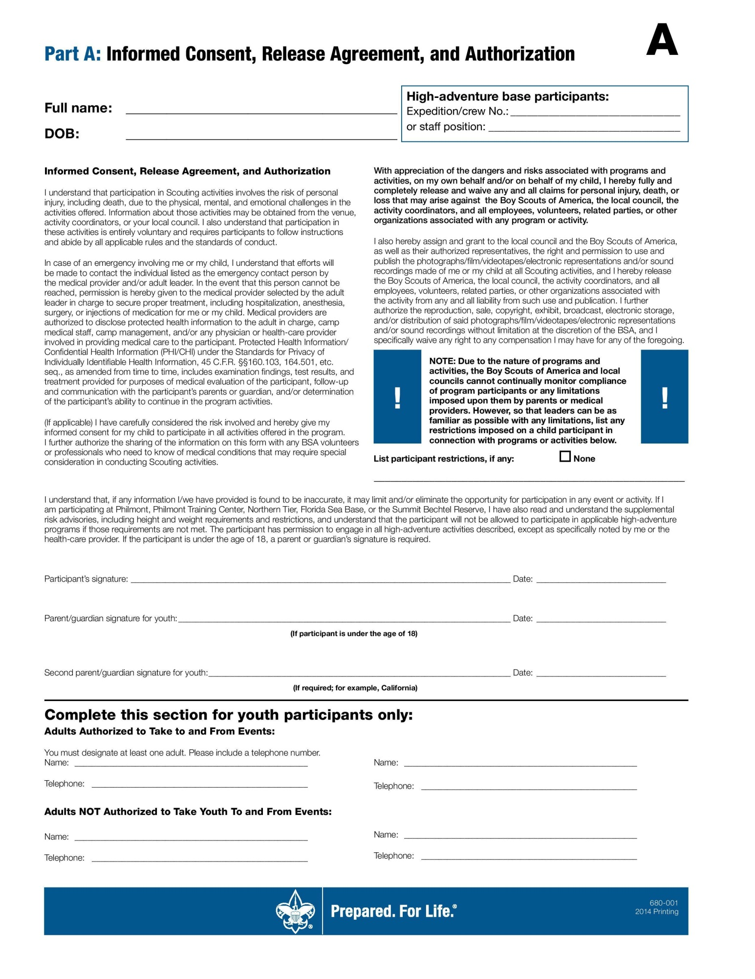
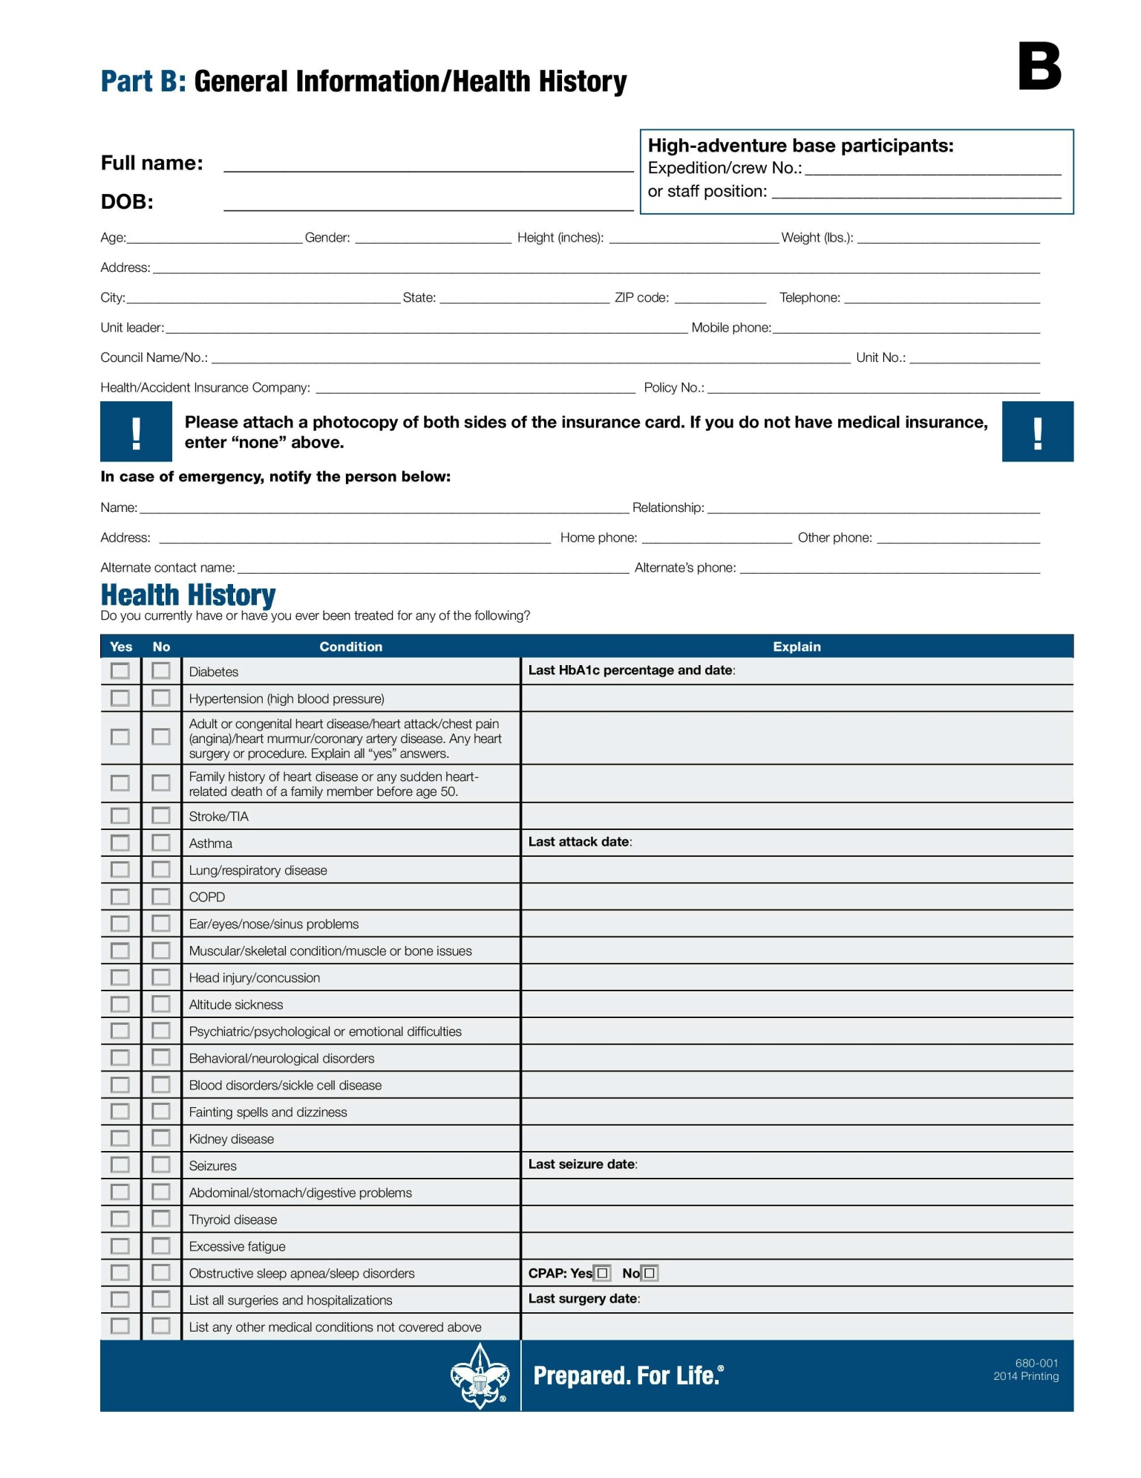
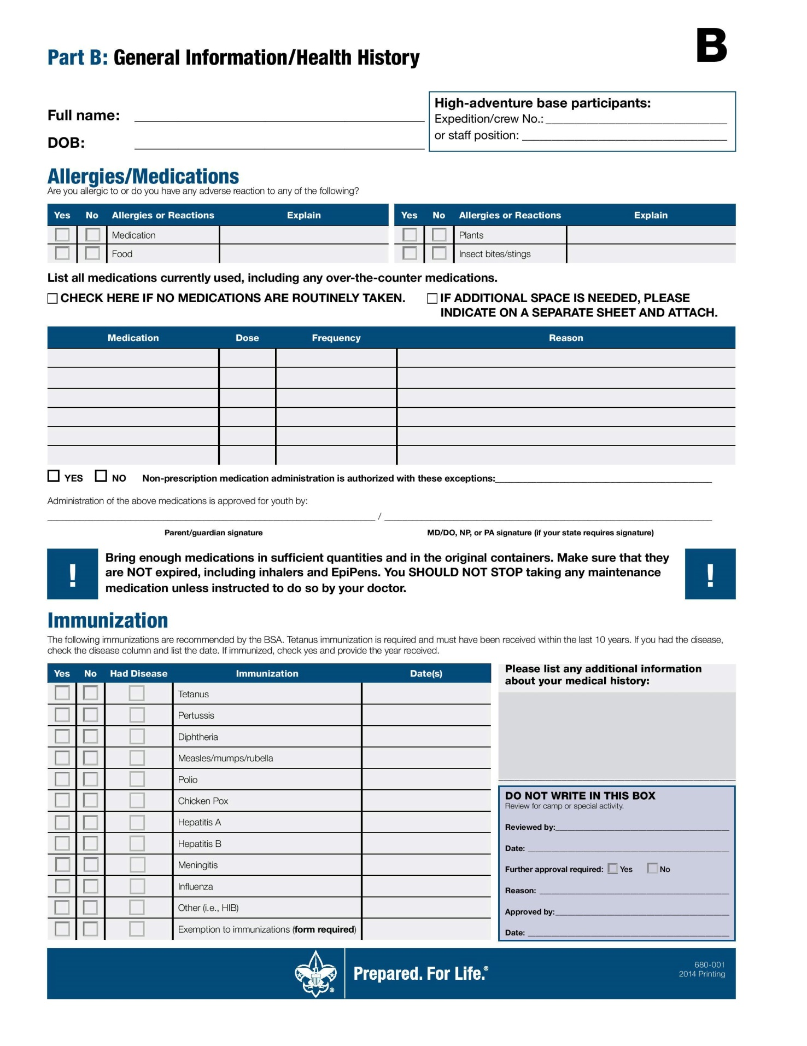
Release for Scout Day Camp June 7th – 9th, 2019
I, ____________________________, for being allowed to participate in ___________________________, agree to indemnify and hold harmless the Norwin Elks Lodge No. 2313, its officers, employees and members from any claim and/or attorney fees arising out of my participation in this event, except for the sole negligence of the Lodge. I further agree the Lodge is not responsible for damage to my property and waive subrogation on any insurance policy I may have. Furthermore, I allow the use of photographs or images arising out of my participation in this event.
__________________________________ __________
Participant Parent or Guardian Date

Release for Scout Day Camp June 7th – 9th, 2019
I, ____________________________, for being allowed to participate in ___________________________, agree to indemnify and hold harmless the Norwin Elks Lodge No. 2313, its officers, employees and members from any claim and/or attorney fees arising out of my participation in this event, except for the sole negligence of the Lodge. I further agree the Lodge is not responsible for damage to my property and waive subrogation on any insurance policy I may have. Furthermore, I allow the use of photographs or images arising out of my participation in this event.
__________________________________ __________
Participant Parent or Guardian Date
Adult leader / Walker |  | Pack # ______ | Note: Please indicate which rank leaders will be walking with
 |  |  |  |  |  |  |  |  |  | Days attending
Indicate Coordinator with * |  | Title  DL=Den Leader  WLK= Walker | Rank  Walking  With |  | DOB |  |  |  |  | Fri. | Sat. | Sun | Phone |  | e-mail
Bushy Tails |  | Parent
Lions &Tigers  (entering Grade K & 1 in Fall) | Pack # ______
 |  |  |  |  |  | Days attending
Scout’s Name | Parent/Guardian |  |  | Walker |  | Fri. | Sat. | Sun | Day Phone |  |  |  |  | Home Phone
Wolves  (entering Grade 2 in Fall) | Pack # ______
 |  |  |  |  |  | Days attending
Scout’s Name | Parent/Guardian |  |  | Walker |  | Fri. | Sat. | Sun | Phone |  |  |  |  | e-mail
Bears  (entering Grade 3 in Fall) | Pack # ______
 |  |  |  |  |  | Days attending
Scout’s Name | Parent/Guardian |  |  | Walker |  | Fri. | Sat. | Sun | Phone |  |  |  |  | e-mail
Webelos/AOL  (entering Grade 4/5 in Fall) | Pack # ______
 |  |  |  |  |  | Days attending
Scout’s Name | Parent/Guardian |  |  | Walker |  | Fri. | Sat. | Sun | Phone |  |  |  |  | e-mail
CALLING ALL CUB SCOUTS!
How would you like to see YOUR DRAWING featured on this year’s Bushy Run District Day Camp Patch?
2019 PATCH DESIGN CONTEST
and if your design is the winner, Day Camp will be FREE for you (a $45 value), you will be honored at Day Camp (June 7-8-9 at Norwin Elks) in front of all your friends, and your drawing will be featured on the patch that is given to all Cub Scouts at Day Camp.
Rules
- Designs must showcase the theme “ You met the challenge – you survived”
- The patch must include the wording:
“Bushy Run Day Camp 2019, ‘Land, Sea, Air and a Fleur de Lis. ()
- Non-traditional shapes for patches are permitted.
- Free day camp incentive may not be “transferred” to a Scout other than the contest winner.
- Contest participants must meet age eligibility requirements for Day Camp 20019 (incoming Lions,(kindergarden thru Arrow of Light Scout – age 11½ or entering 5th grade.)
- No entries will be accepted after April 15 and the judges’ decision is final.

Draw and color your design in the space below:
Use back if more room is needed

Cub Scout’s Name ______________________________ Pack # __________
Parent/Guardian Name _________________________ Phone ______________
MAIL TO: BSA Westmoreland Fayette Council, ATTN: Bushy Run Patch Contest,
2 Garden Center Drive, Greensburg PA 15601 NO LATER THAN APRIL 27
Extra Tee Shirts | Pack # _________
Name | Size | Adult/  Bushytails |  |  |  |  | Home Phone
John Doe | Med | Adult
Johnny Smith | XSm | bushytail
About the tee shirts for Day Camp:

Each Cub Scout will receive a tee shirt on Friday morning. Lyons, Tigers, Wolves, and Bears will receive a Childs medium and the Webelos and AOL’s will receive a child’s large. If by chance you have a scout that needs a larger shirt, Please mark that on the extra tee shirt form.

We ask that the Scouts wear their tee shirts all three days.

We will have two meetings with the walkers at Norwin Elks dates to be announced.

REGISTRATION DUE BY MAY 1, 2019

